CMPE 470L Final Project Report
By Eman Sarah Afi (A00051)
American University of Bahrain
Spring 2022

Table of Contents
Objective: 2
Introduction & Problem Statement: 2
Procedure: 3
1. Understanding the flow of the traffic signals: 3
2. Drawing the data path & control units of the system: 4
3. Constructing the ASM of the controller: 5
4. Writing the VHDL module for the clock: 7
5. Writing the VHDL module for the controller’s ASM: 8
6. Writing the VHDL module for the timing system: 11
7. Writing the VHDL module for the East segment timer display: 12
8. Writing the VHDL module for the top-level VHDL module: 13
9. I/O implementation: 16
10. Pin assignment for the circuit: 18
Testing of the circuit & conclusion: 19

Objective:
This final project aims to make us implement the entire semester’s learning outcomes using the following tools: Intel Quartus IDE software, Terrasic DE-10 Lite board, and other hardware components that can be obtained when necessary.

Introduction & Problem Statement:
An algorithm state machine (ASM) is a method that allows us to design the Finite State Machine, which is a computational model that enables the model, at any input, to be in a specific state out of a limited number of states derived based on the problem. VHDL is a language that can describe the behavior of digital logic circuits. In this project, we must use our learning outcomes throughout the semester and previously designed components from previous experiments to implement a real-life example of a traffic light system. Thus, the experiment will be divided into three parts: The first part is theoretical, as we will understand the traffic lights’ flow, draw a block diagram of the system, and implement the flow as an ASM. The second part would include implementing the top-level design file and the necessary components into VHDL modules using Quartus. The last part is related to hardware and would require us to construct the circuit using various tools.

Procedure:
To design the design problem’s Finite State Machine, the following must be done:

Understanding the flow of the traffic signals:
First, to understand the project’s problem statement, we must construct a table to understand the flow of traffic signals. The table is the following:
State definition | A | B | C | D | E-F | Time | Condition
S0 | G | G | R | - | R | 60 | If Se or Sf = 0 & Sa = 1, S12 goes to S0.
S1 | G | Y | R | - | R | 2
S2 | G | R | R | - | R | 1
S3 | G | R | Y | - | R | 2
S4 | G | R | G | - | R | 30
S5 | Y | R | G | - | R | 2
S6 | R | R | G | G | R | 10 | If Sd = 1.
S7 | R | R | Y | - | R | 2
S8 | R | R | R | - | Y | 2 | If Sd = 0, skip from S5 to S8.
S9 | R | R | R | - | G | 20
S10 | R | R | R | - | G | 5 | If Se or Sf = 1 & Sa = 0.
S11 | R | R | R | - | Y | 2
S12 | Y | Y | R | - | R | 2
Fig 1: Table demonstrating traffic signals’ flow

Drawing the data path & control units of the system:
For the control units of the system, we have the following:
- A converter that converts the onboard 50 MHz clock pulse to 1 Hz.
- A timing system that is a counter which counts from 0 to 60 but resets when necessary.
- A timer that counts down from 90 to 0 for the East segment.
- A Hexadecimal to BCD converter.
- Two BCD to 7-segment display converters.
For the data path, there is:
- A master switch that will reset all the components.
- The “clkout” output from the clock pulse converter circuit will be used in all the parts.
- The output of the timer’s circuit will be converted from Hexadecimal to BCD, and it will be displayed through two 7-segment displays.
The inputs of the system are:
- The onboard 50 MHz clock pulse.
- The reset switch.
- The four sensors: Sa, Sd, Se, and Sf.
The outputs of the system are:
- The two 7-segment displays: O0 & O1.
- The traffic light signals: Ar, Ay & Ag (for traffic lights A of the east segment), Br, By & Bg (for traffic lights B of the east segment), Cr, Cy, Cg & Dg (for traffic lights of the west segment), Er, Ey & Eg (for traffic lights E of the north segment), and Fr, Fy & Fg (for traffic lights F of the south segment).

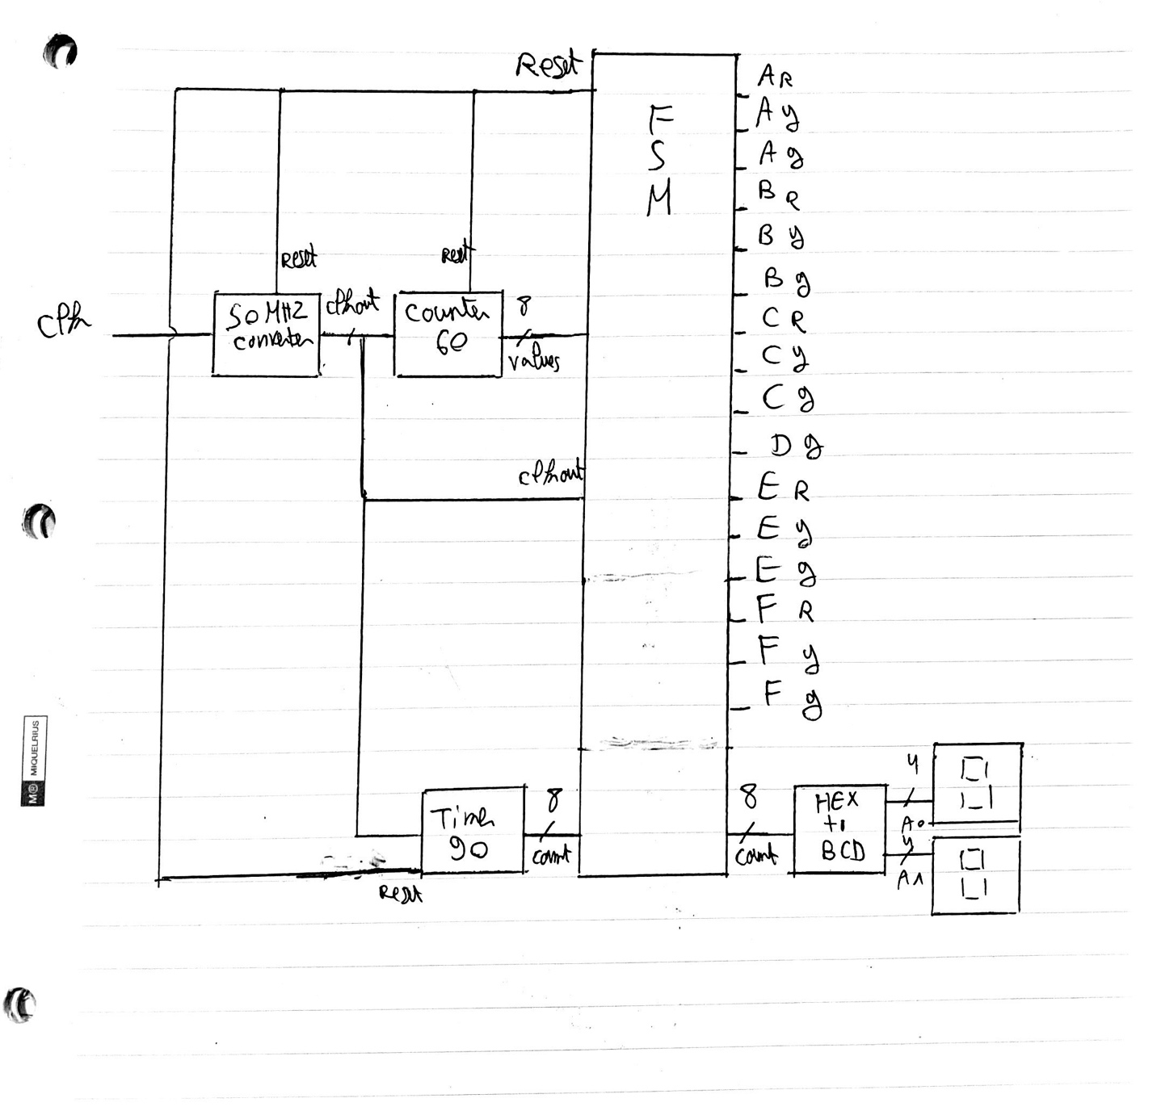
Fig 2: Block diagram of the data path & control units of the system

Constructing the ASM of the controller:
According to the implemented table in figure 1, we can construct the corresponding ASM to the table, which is the following:
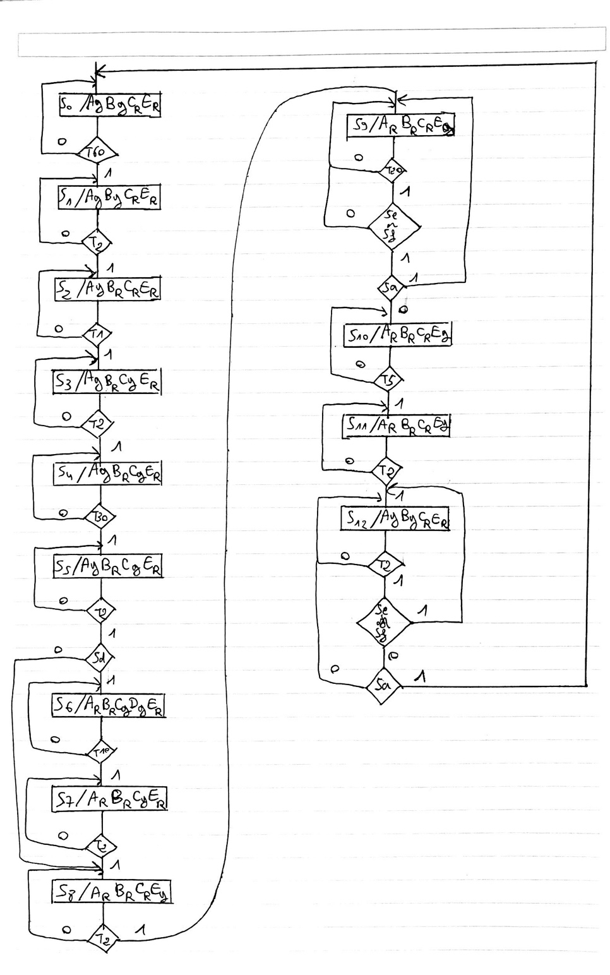
Fig 3: ASM of the traffic lights’ controller

Writing the VHDL module for the clock:
To begin, the clock circuit that would alter the board’s 50 MHz clock pulse to a 1 Hz clock pulse so that we can manage to work with the entire circuit, as working with 50 MHz would make it rather difficult to view the results of the whole circuit as it will function rapidly.
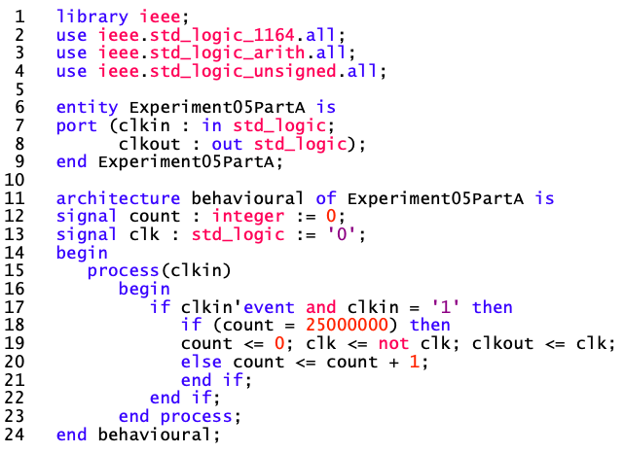
Fig 4: VHDL module for the Clock Pulse Converter

Writing the VHDL module for the controller’s ASM:
For this VHDL module, we have two process features. The first one, P1, establishes what would happen if the reset switch were on and that the present state would change & the counter would reset within a clock pulse. The second one, P2, is a case situation according to the current state in the ASM; it will show us the output and when the present state changes to its next state according to some precise conditions that are implemented as if-else statements.
The timing system will be implemented as a component, and it will be introduced in the if-else statements of the case statement. Therefore, the counter will reset when it reaches a specific value, and the state will change. Also, constants were created in the VHDL module for that reason. Moreover, the sensors were implemented alongside the counter in the if-else statements of the case statement.
Note that as the sensors that we used were active low, we had to switch the values of the sensors that function according to the emphasized conditions in figures 1 & 3, from 0 to 1 and vice versa.
Plus, the clock component from figure 4 has been implemented that the controller’s clock will function with a 1 Hz clock pulse so we can see the actual results.
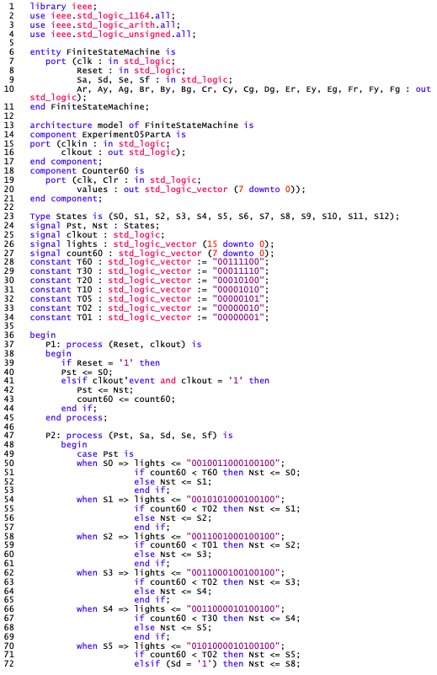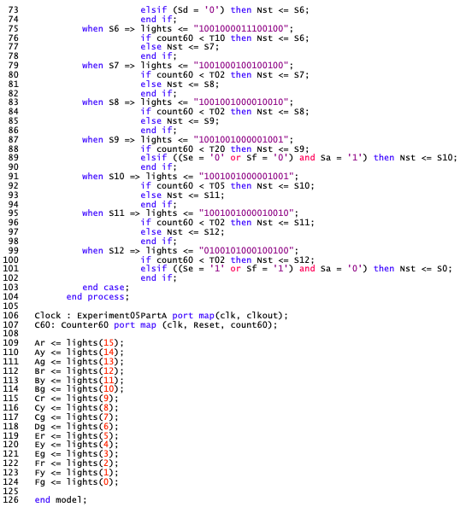
Fig 5: VHDL module for the controller’s ASM

Writing the VHDL module for the timing system:
The VHDL module of the counter for the timing system has been implemented with the addition of generalizing the value N in the counter. Thus, its range would be from 0 to N-1. In our case, we decided that N would be from 0 to 60. Furthermore, we added a synchronous Reset input into the module before compiling it. The clock pulse converter from figure 4 was also added to ensure that the counter would count from 0 to 60 per 1 Hz clock pulse. In the controller’s VHDL module, we also mentioned that when the states change, the counter resets and starts counting again.
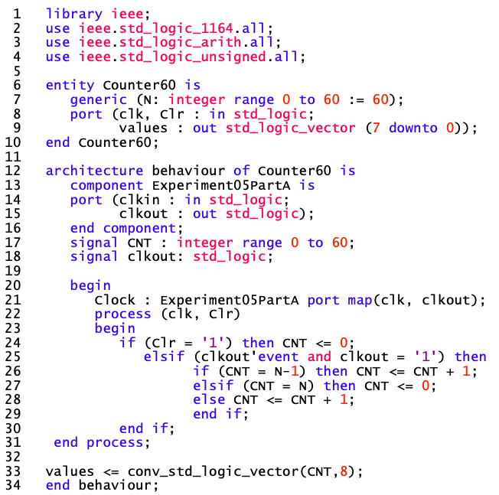
Fig 6: VHDL module for the timing system

Writing the VHDL module for the East segment timer display:
For the timer, it is like the timing system’s VHDL module from figure 6. Instead, it will count down from 90 to 0. Therefore, we change the positive sign to negative, changing the generic integer N’s range from 0 to 90.
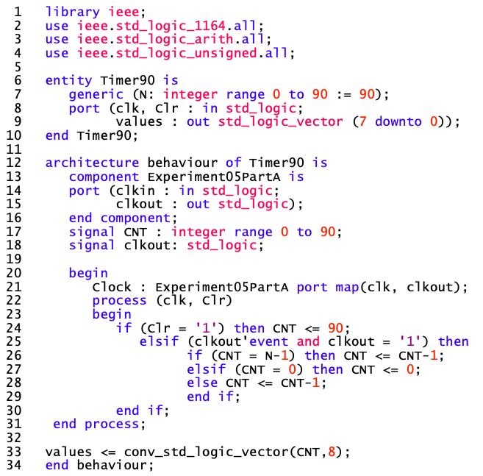
Fig 7: VHDL module for the timing system
Then, to display the output on the two 7-segment displays, we will be converting the Hexadecimal output to BCD and interface it on the two 7-segment displays in the top-level entity VHDL module.

Writing the VHDL module for the top-level VHDL module:
To convert a Hexadecimal value to its BCD equivalent, we first had to convert it into a decimal number. Then, we split the decimal number by the following series of mathematical operations.
Suppose that the variable v is composed of two digits in the structure of n1n2. The following operations to separate the two digits are the following:
- n2 = v mod 10
- v1 = v / 10
- n1 = v1 mod 10
Once that is done, we match the values with the corresponding BCD equivalent numbers, and then we concatenate them to get the output.
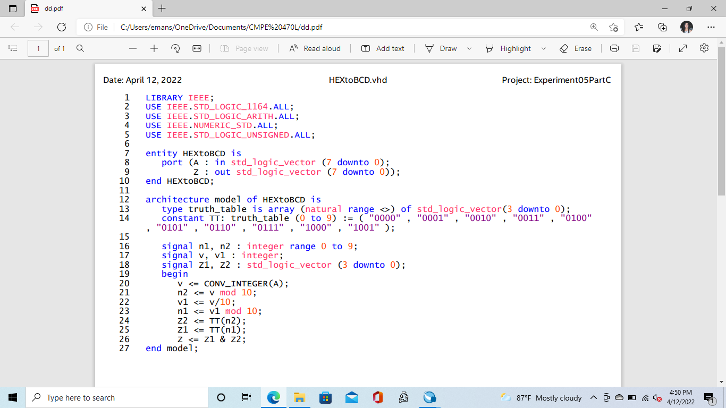
Fig 8: VHDL module for the HEX to BCD converter
The outputs were used as an array to implement the BCD to 7-segment display decoder. The VHDL module has also converted the BCD input A into an integer and matched it with its corresponding output from the array that displays the results according to the BCD to the 7-segment display decoder truth table. Note that as the Terrasic board functions with HEX to 7-Seg, we had to flip the values of the outputs on the actual truth table from 0 to 1 and vice versa.

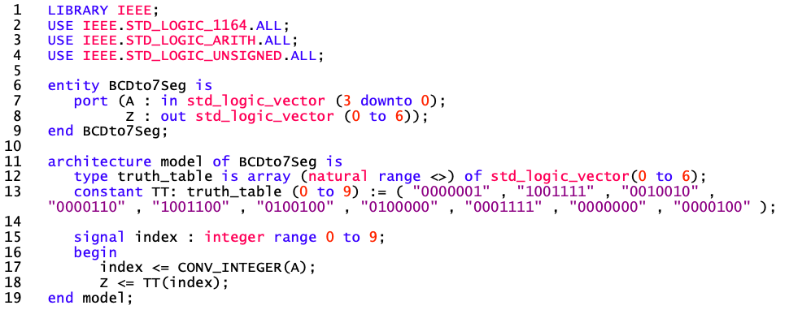
Fig 9: VHDL module for the BCD to 7-Segment display
The top-level VHDL module combines all previously implemented components into one file. To display the timer on two 7-segment displays, the signals count, Z, A0 & A1 were created. The output “count” of the timer will be converted into BCD as the output “Z”, and then it will be implemented as A0 and A1 into two 7-segment displays. Plus, the inputs and outputs were correctly specified in the file so the circuit could function.
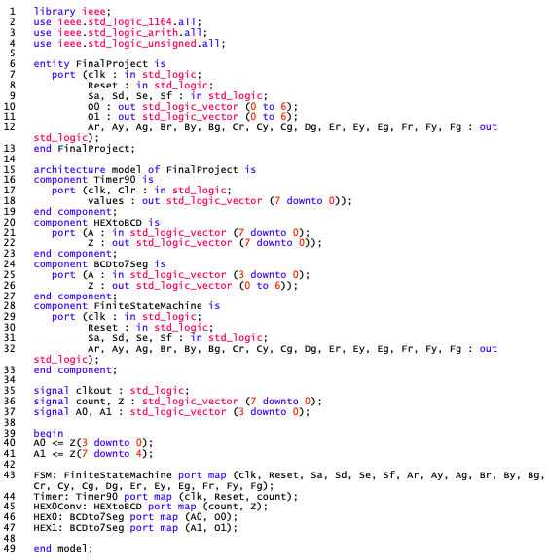
Fig 10: VHDL module for the BCD to 7-Segment display

I/O implementation:
To construct the hardware circuit for the project, the following components were used:
- A breadboard and four mini modular breadboards to place the components.
- Four active low infrared barrier sensors for Sa, Sd, Se & Sf inputs.
- Five mini 5V traffic light LED display modules to represent the traffic lights for the five segments A, B, C, E & F.
- One green LED to describe the green light for D.
- Wires.
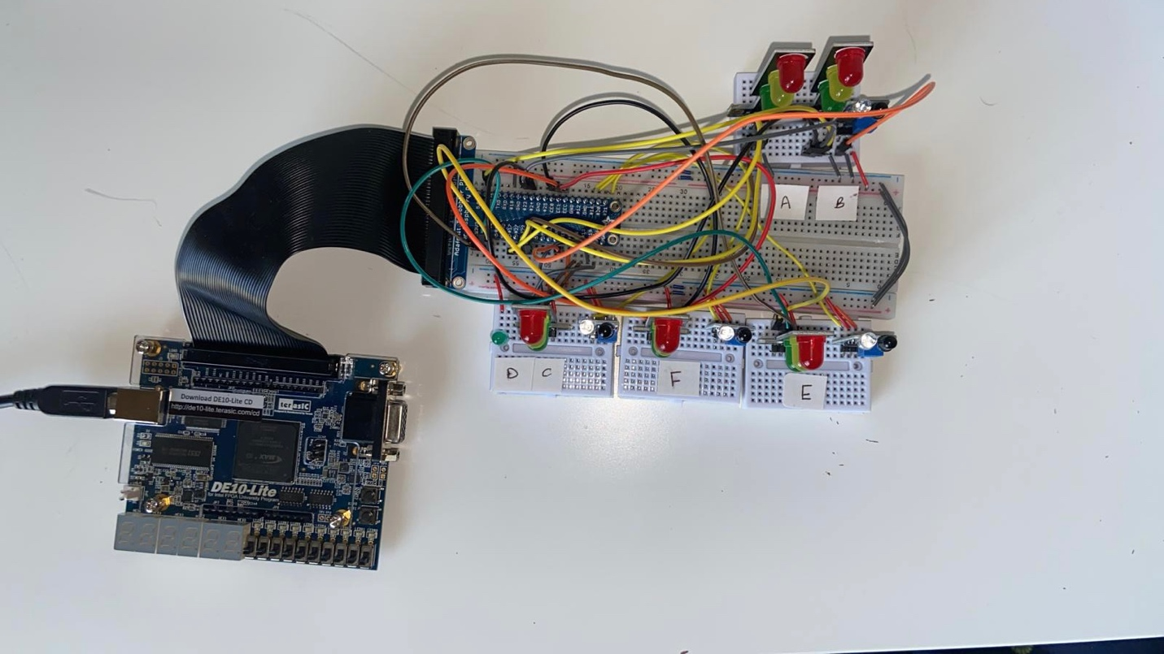
Fig 11: Top view of the circuit’s hardware implementation

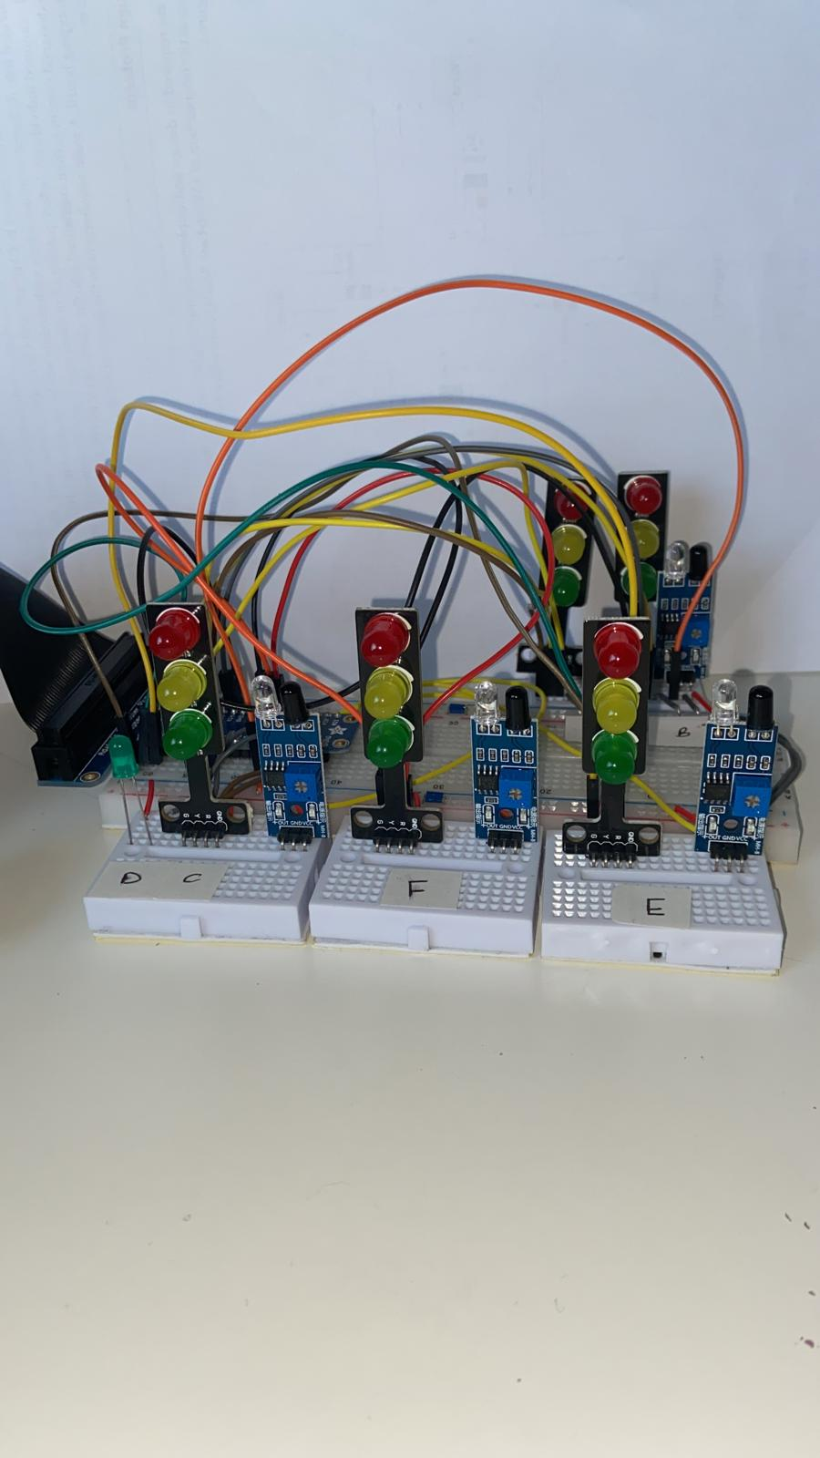
Fig 12: The circuit’s hardware implementation when powered off
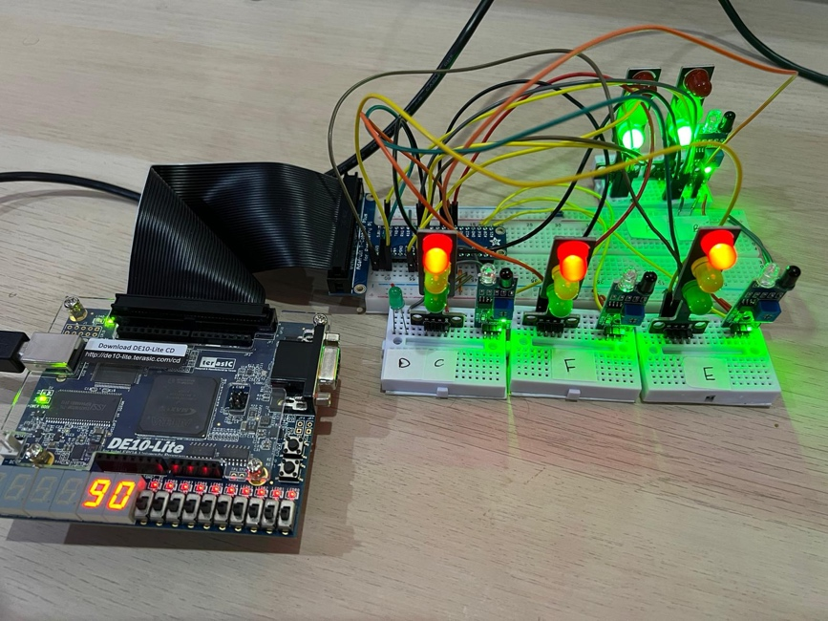
Fig 13: The circuit’s hardware implementation when working

Pin assignment for the circuit:
To connect the VHDL module to the implemented hardware, the following pin assignments must be done:
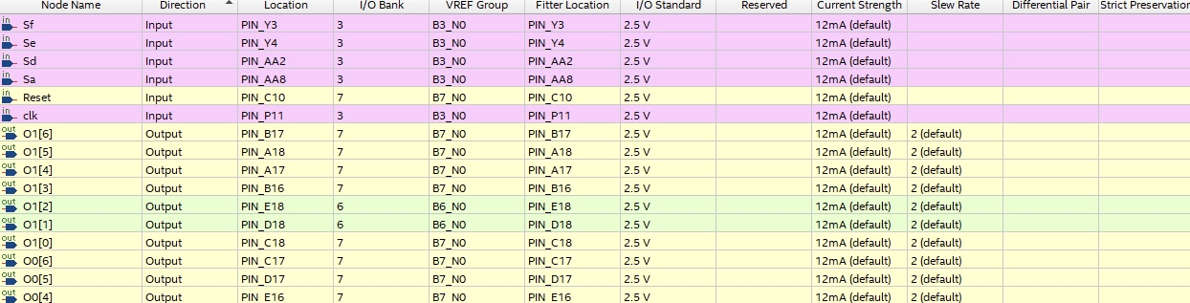
Fig 14: The pin assignment for the inputs
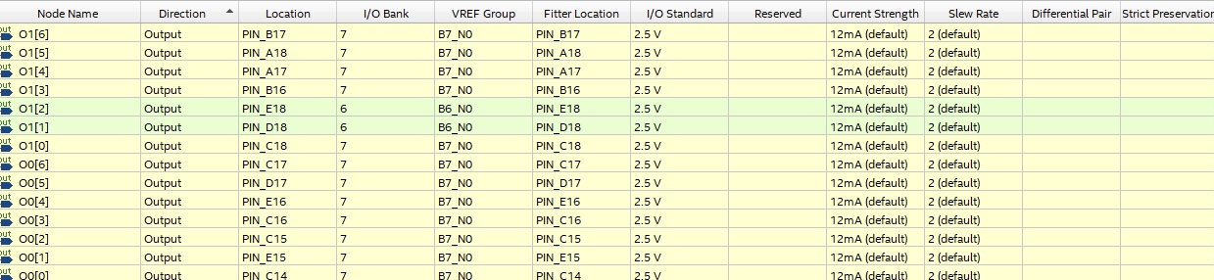
Fig 15: The pin assignment for the two 7-segment displays
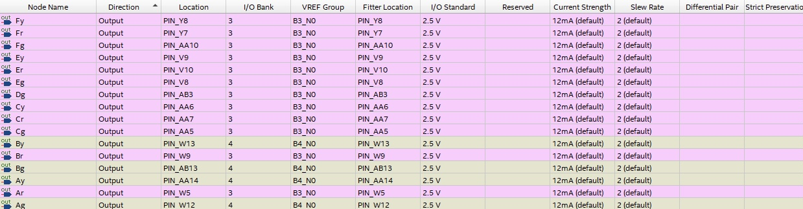
Fig 16: The pin assignment for the traffic lights

Testing of the circuit & conclusion:
The experiment is conducted by first compiling the VHDL module on Quartus and then implementing it from the hardware perspective using the Terrasic DE-10 lite board once the pins are correctly assigned according to the compiled module. We confirmed that the experiment worked mostly during the hardware implementation by following a traffic lights sequence presented in figures 1 & 3. The only issues were with the counter at state 6 when the green light for D did not light up for 10 seconds, and the timer cannot be reset to S0 unless manually. Other than that, the flow of the traffic lights was implemented correctly on the circuit’s hardware.
To conclude, the primary learning outcome from this experiment is modeling an ASM of a design problem directly from a real-life problem using VHDL. And the experiment also allowed us to implement our previous learning outcomes regarding converting clock pulses using a VHDL module, implementing a Modulo-N counter for the timing system & the timer, converting a Hexadecimal value to its BCD equivalent by using mathematical expressions, and displaying its outputs in 7-Segment Displays.

